St. Mary's Primary School

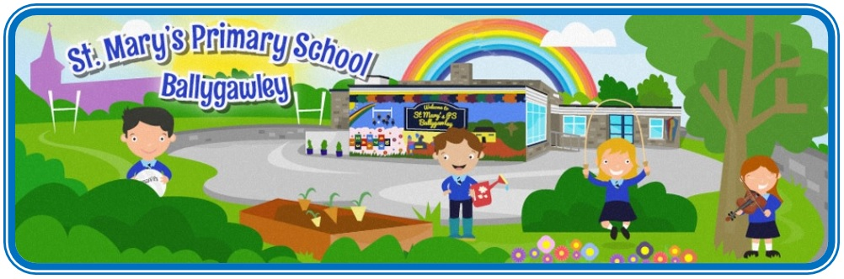

School
Prospectus
2023-2024

Contents

Welcome Address p.3
School Information p.4
Aims of the School p.8
Religious Education p.8
Pastoral Care / Child Protection p.9
Curriculum p.11
Special Needs p.12
Assessment p.12
Homework p.13
Positive Behaviour p.15
School Uniform p.17
Admissions Information p.18

Welcome to
St Mary’s Primary School
Our School Vision

At St. Mary’s we aim to promote the ethos of a Catholic School by creating a safe and happy School Community where:

- Everyone feels valued as a member of our inclusive team in an
atmosphere of fairness and respectfulness.

- High standards of learning and teaching take place in a fun, caring and
stimulating environment which enables everyone to reach their full
potential.

Dear Parent,

St. Mary’s is in the Parish of Errigal Ciaran, serving the community through the provision of a caring and effective service, which enables children to make the most of their potential for academic, religious and human development. This is achieved through the commitment and dedication of the excellent teaching and support staff network, who work closely together as a team to ensure the highest possible standards of provision for the children in our care.

Our school is a happy, hardworking, and successful environment. Your child will be most welcome and we trust that the next seven years will be happy and rewarding.

This prospectus attempts to give you a broad insight into the high quality of education provided for your child in the school. As no booklet can really convey the atmosphere, which exists in our school, I warmly invite you to visit and see for yourself the all-round educational experience, which is ‘St. Mary’s’.

________________________________

Mrs Cara Donnelly
Principal
School Information
Board of Governors Chairperson: Mr. Austin Walsh

Principal: Mrs. Cara Donnelly

The school, situated in the village of Ballygawley, has a present enrolment of 135 pupils and most pupils come from either the village or from within a radius of two to three miles from the school.

We have a teaching staff of five plus one part-time teacher. There are four classes in the main building and another in a mobile classroom. There is a large dining / assembly room, a library, staff room, Principal’s office and two smaller rooms, one of which is used by the school secretary and the other for Special Needs Support and visiting peripatetic music teachers.

As well as providing the normal primary school curriculum the school is involved in an on-going programme of activities, right across the curriculum, with neighbouring schools.

The pupils are involved in regular sporting activities, both during the school day and as part of the schools after school provision. These include Gaelic football, soccer, Sporty tots, Multi-sports, which include basketball / netball and volleyball, Yoga, handball etc. Key Stage 2 pupils also attend swimming lessons. Pupils take part in our school’s Annual Sports Day. Some pupils also represent our school in cross country running and athletic events.

Pupils are given the opportunity to play classical instruments such as violin, cello and flute. Pupils can avail of individual musical tuition from EA Southern Region tutors. The school also provides tuition in guitar and all children from Year 5 – 7 can avail of this. In addition to that which is provided within the curriculum, drama tuition is also catered for during school each Wednesday. The school presents an annual Christmas Production for parents and visitors. The choir in the school also participates in the preparation for the Sacraments of Confirmation, Holy Communion and Reconciliation.

The experienced and dedicated staff have the overall well-being of the children as their priority. A happy atmosphere permeates throughout the school allowing children to relax, and effective learning to take place.
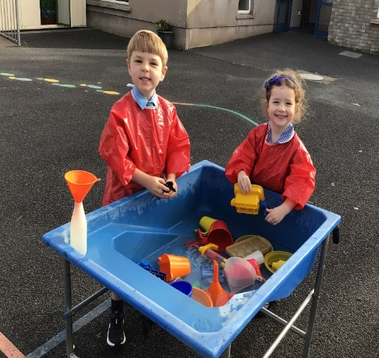

School Hours

Breakfast Club 08.00 – 08.30
School Begins: 09.00
Break: 10.45-11.00
Lunch: 12.00 – 12.45 Year 1-3
12.45 – 13.30 Year 4-7
School Ends: 14.00 (years 1 & 2)
14.50-15.00 (years 3-7-staggered home time)

For the month of September, the Primary 1 children’s day ends at the earlier time of 12.00.

Supervision of pupils begins at 8.30am each morning. All children should be collected from school at the designated times unless engaged in school organised activities.

The school will be closed during the months of July and August. All other planned holidays are distributed at the beginning of the academic year.

It is the aim of St. Mary’s to fully involve parents in the education of their children and to inform and consult with them regularly about their children’s progress. The arrangements are:

Induction Programme
- Primary 1 children are invited into the school in June prior to enrolment.

Progress Reports
- Mid- way during the first term Parents are invited to a consultation with their child’s class teacher to discuss the progress and the programme of study for the remainder of the year.

- A written report is issued in June of each year in which the performance of the child in each of the Curricular Areas is reported.

- Parents are very welcome to contact the school to arrange additional meetings.

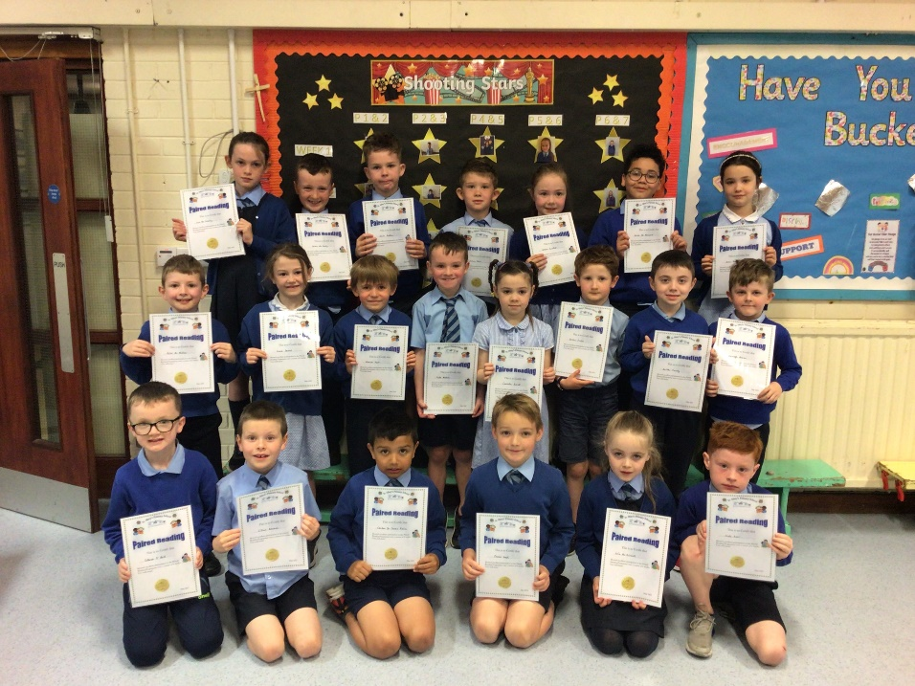

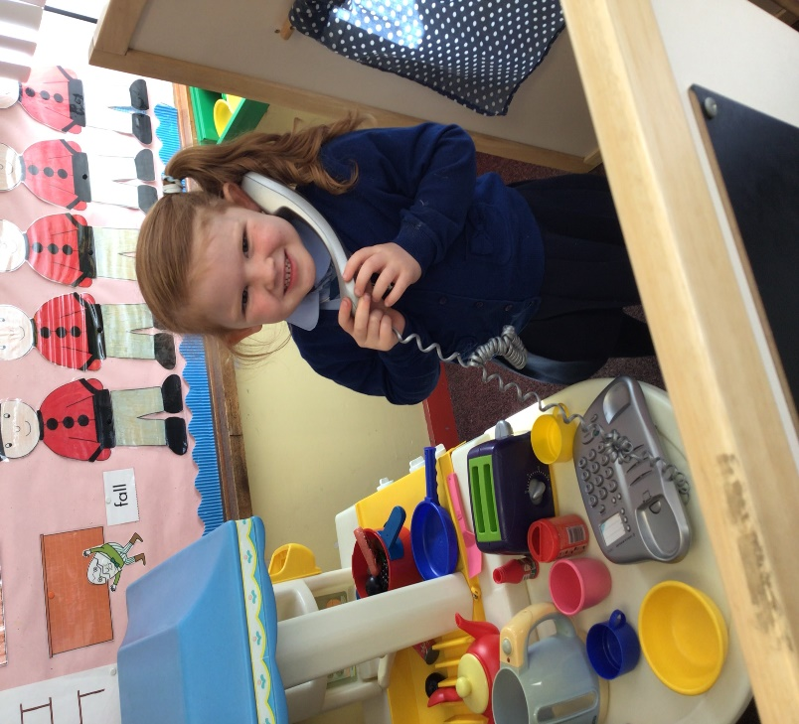

Play based learning in Foundation Stage

Cross Country

School Personnel

Governors

Mr Austin Walsh (Chair) Trustee Representative
Mr Garrett Loughran Trustee Representative
Mrs Una Canavan DENI Representative
Mr Ruairi Maguire SELB Representative
Mr Michael Mc Crory SELB Representative
Mr Stephen Donaghy Teacher Representative
Mrs Pauline McGinley Parent Representative
Mrs Cara Donnelly Principal St. Mary’s Primary School

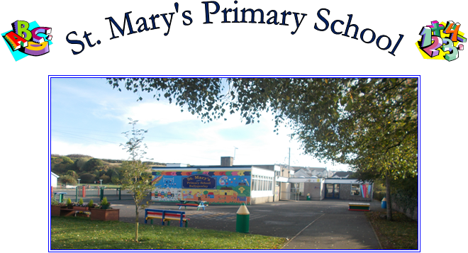
Teaching Staff

Mrs Cara Donnelly - Principal
Mrs Patricia Hagan - Year 1/2
Miss Lisa Hurson - Year 2/3
Miss Joanne McCaughey - Year 4/5
Miss Oonagh Mc Aleer - Year 4/5
Mr Stephen Donaghy - Year 5/6
Mrs Ciara Phair - Year 6/7
Mrs Karen McGarrity - SEN Support Teacher

Ancillary Staff

Mrs Charleen McKenna - Secretary
Mr Brendan McClenaghan - Caretaker / Patrol Person
Mrs Hilary Mc Bride - Foundation Stage Classroom Assistant
Mrs Orla Mc Kenna - Foundation Stage & SEN Classroom Assistant
Mrs Nicole O’Donnell - SEN Classroom Assistant
Mrs Sinead Mallon - SEN Classroom Assistant
Miss Aimee Fox - SEN Classroom Assistant
Mrs Liz Donnelly - SEN Classroom Assistant
Mrs Ann Marie O’Neill - Cook in Charge
Mrs Tracy Mc Kenna - Kitchen Assistant
Mrs Sharon Shevlin - Kitchen Assistant
Mrs Charlene Brady - Kitchen Assistant
Miss Martina Mc Dermott - Cleaner

Religious Education

Catholic Education is the centre point of the entire child’s personal and intellectual development. The Religious Education of the pupils is accomplished in two equally important and complementary ways:

- Through the totality of experience in the school;
- Through the Grow In Love Religious Education Programmes.

The staff are aware of the spiritual needs of the children and of the important role Religious Education plays in a child’s upbringing. With assistance and encouragement from our Parish Priest, Fr. O’Dwyer, we ensure that these needs are catered for.

The children are prepared for the Sacraments of Reconciliation and Eucharist in Year 4, and for Confirmation in Year 7. Parents have a right of withdrawal from all of RE or part of RE.

Pastoral Care / Safeguarding and Child Protection

The Pastoral Care of the children in St. Mary’s Primary School is of paramount importance. We aim to provide a happy, safe environment where each child will be given the opportunity to reach his/her true academic, social, emotional and spiritual potential. The primary objective of the school ethos is to ensure that pupils are shown consideration and respect and are encouraged and expected to treat others in the same way.

In St. Mary’s we:
- Promote the children’s self-esteem through praise and reward.
- Ensure each child feels that he/she is appreciated for their contribution to the life of the school.
- Provide children with a secure and happy environment where they feel safe and encouraged to learn.
- Ensure that each child is given the opportunity to experience success.
- Establish good partnerships with the parents and guardians and to work positively with other agencies including Health and Social Services, Clergy, EWO, Inclusion and Diversity Team, RISE Team and other educational bodies.

Class teachers strive to know each child in their care and to form positive and worthwhile links with parents and carers. Classroom assistants and ancillary staff help to ensure the safety and well-being of each child and to enhance their learning. Children are always encouraged to do their best and are regularly nominated for recognition of effort in the many areas of school life. Parents are welcome to discuss their children’s progress and any other significant matters at any time.

Parent’s Concerns
Any parent, who has a concern about their child’s happiness, progress or safety, is asked to contact the school and make an appointment to meet and discuss the problem with the child’s teacher or the Principal.

Safe Guarding and Child Protection

One way we seek to protect our pupils is by helping them to learn about the risks of possible abuse, helping them to recognise unwelcome behaviour in others and acquire the confidence and skills they need to keep themselves safe. Much of this work is undertaken in class and at assembly.
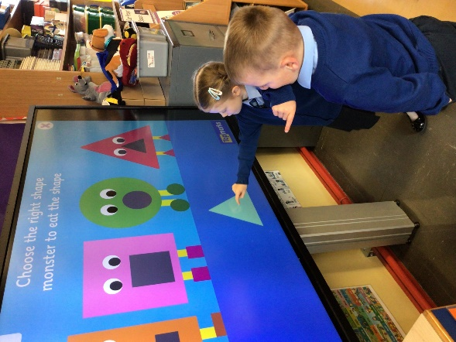
The purpose of the following procedures on Child Protection is to protect our pupils by ensuring that all adults who have responsibility for our children – parents, teachers, non-teaching staff and volunteers – have a clear guidance on the action which is required where concerns about a child’s safety become apparent. The overriding concern of all caring adults must be the care, welfare and safety of the child. The welfare of each child is our foremost consideration.

ETI in 2015 reported that ‘the quality and provision for pastoral care in the school is outstanding. There is an inclusive and child-centred ethos in the school with very good working relationships, built upon mutual respect.’
The school has comprehensive arrangements in place for Safeguarding children.

How can a Parent Raise a Concern

I have a concern about my child’s safety.

I can talk to my class teacher.

If I am still concerned, I can talk to the designated teacher Mrs Hagan or our two deputy designated teachers for child protection, Mr Donaghy or Mrs Donnelly, the Principal.

If I am still concerned, I can talk/write to the
Chairperson of the Board of Governors,
Mr Austin Walsh

If I am still concerned I can contact the NI Public Services Ombudsman
Tel: 0800 343 424

At any time a parent can talk to a social worker at the

Gateway Team Tel: 0800 7837745

or the

PSNI Public Protection Unit Tel: 101

Our Curriculum

The curriculum is the sum of all the learning experiences present for each child, those planned
by the teacher, and those that emanate from our school ethos and environment. Our curriculum takes into account the uniqueness of each child and his/her individual needs. As a Catholic school we aim to develop attitudes and values reflective of our Christian ethos. Our Curriculum centres around the learning areas of Language and Literacy, Mathematics and Numeracy, the Arts, the World Around Us, Personal Development and Mutual Understanding and Physical Education. The Learning experiences for the children are of course much broader that this and across the curriculum we have an emphasis on the development of skills and capabilities for lifelong learning and for operating effectively in society.
These whole curriculum Skills and Capabilities include Thinking Skills and Personal Capabilities and Cross-Curricular Skills. Our links with the local primary schools are longstanding and allow children to develop positive attitudes and relationships. We also have close links with neighbouring grammar and secondary schools, working in partnership with them to deliver a variety of learning opportunities for the benefit of all the children. The teacher training colleges recognise St. Mary’s as a learning centre and are involved with us in a number of curricular initiatives.

Qualities of confidence, self-esteem and consideration towards others will be developed alongside increasing competence in the basic skills. A variety of teaching approaches centred on practical first-hand experience will be pursued.
The curriculum is not just about formal lessons. It includes all the opportunities for learning provided by the school such as:

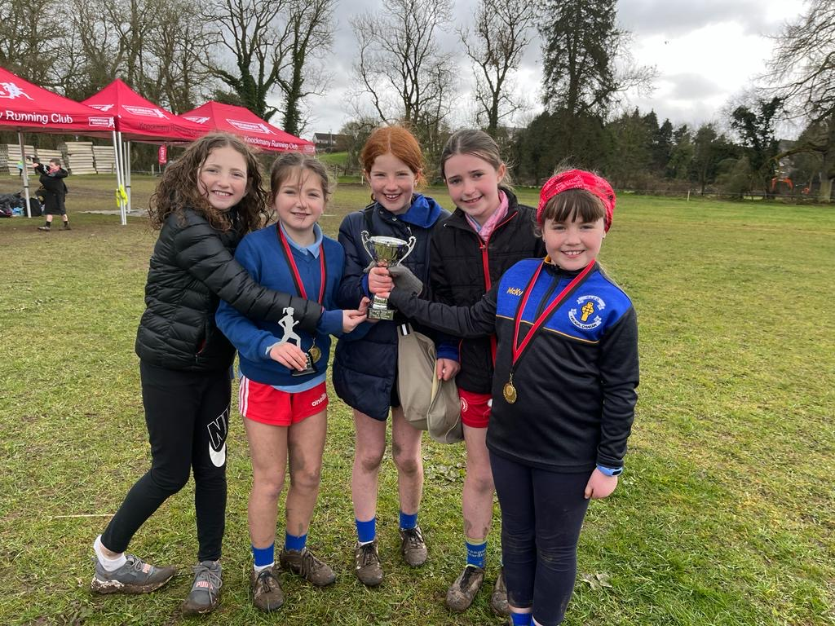
- Sport – Gaelic Football, Hurling, Soccer, Basketball, Netball & Swimming
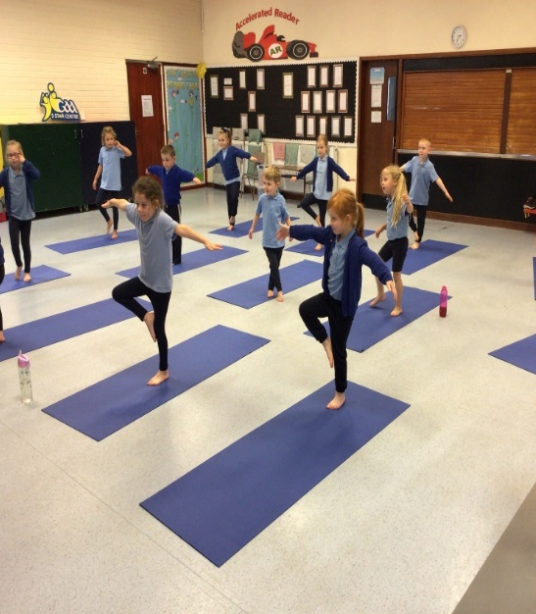
- Music – String & Brass Classical Tuition.
- Cycling Proficiency – Year 7
- Drama
- Quiz Competitions – Credit Union and Cumann Na mBunscol
- Educational Visits – Day Trips & Special Guests
- Art Competitions
- Basketball, Multisport, Sporty-tots, Pilates, gymnastics, Mindfulness, Drama, Coding, Technology. etc

Homework

Parents have a wide range of responsibilities in relation to their children and success depends greatly on liaison between home and school. In St. Mary's, Ballygawley, we value co-operation with the parent or guardian. You, the parent, have an important part to play, especially in the area of homework. Homework is not only an essential part of our pupils' learning but is an opportunity for parents to become involved in their children's learning and progress.
Homework is reinforcement of work/learning done in school and is an excellent home/school link. Working together, with the pupil's best interest at heart, proves to be a most successful method of helping to educate your child. Parents are encouraged to sign all homework and reading records.

Special Educational Needs

In order to ensure that every child realises his/her true potential at school the teachers will ensure that activities and content of lessons are carefully matched to individual needs. Every effort will be made to provide maximum access to the curriculum for children with Special Educational Needs. Teachers will liaise closely with the parent in drawing up Individual Education Plans for their child and regular reviews of progress will be initiated.

The school’s Special Needs Policy is in line with the Education (NI) Order 1996. This enables the staff to fully implement the requirements of the Code of Practice on the Identification and Assessment of Special Educational Needs published by DENI.

Positive Behaviour

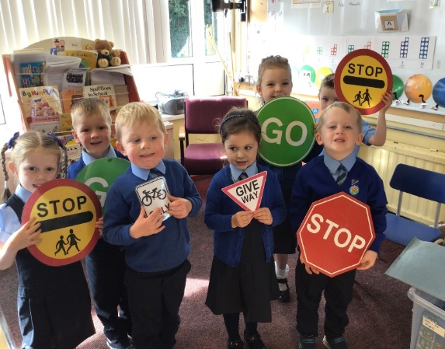
We believe that a positive approach must be used in maintaining school discipline. Our approach will closely correspond to the aims of the school. We recognise that a consistent whole-staff approach to discipline is essential and that the Principal has a key role to play in ensuring that standards are maintained.

We will endeavour to:
- Provide a happy, caring and stimulating school
environment;
2. Treat children with fairness and consistency;
3. Encourage good social and personal skills, self-respect and respect for others;
4. Nurture self-esteem, confidence and independence;
5. Develop in our pupils a set of moral and religious values in keeping with the Christian and
Catholic ethos of the school.

The main elements of this approach will be:
- Good pupil-teacher relations;
- Engaged and stimulating learning;
- Classroom organisation;
- Teaching methods;
- An awareness of and sympathy towards the needs and requirements of individual pupils;
- Consistent encouragement and praise.

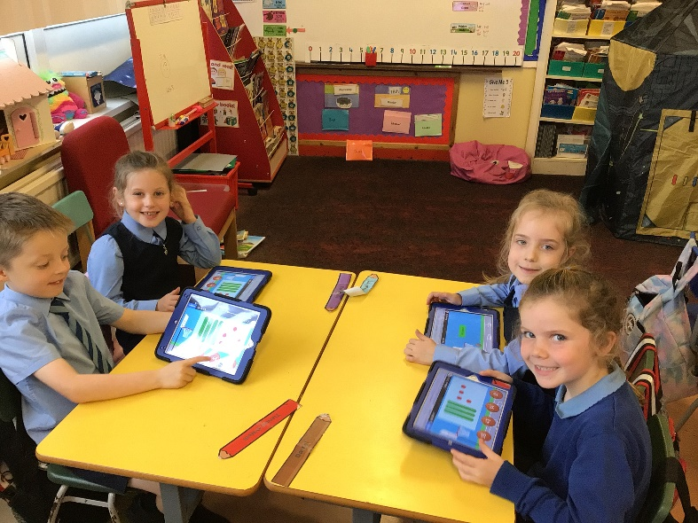
We aim to provide a well-ordered, disciplined, safe and caring environment for our pupils. We ask that parents co-operate with us to achieve this.

School Uniform

There is a School Uniform which is expected to be worn at all times-
.

Boys: Light blue shirt,
Royal blue jumper,
School tie
Navy trousers

Girls: Light blue shirt
Navy pinafore / skirt
School tie
Royal blue jumper / cardigan

PE: Light blue T -shirt and Shorts / Plain Navy Jogging Bottoms
Footwear: All children should wear trainers / plimsolls

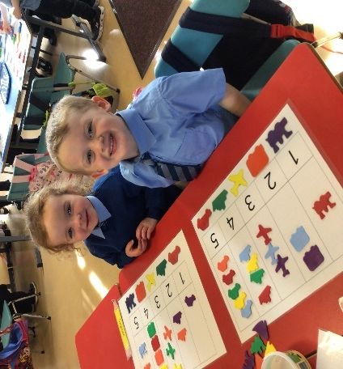
School uniform can be obtained at a variety of outlets and is something, which gives the children a sense of identity with the school.
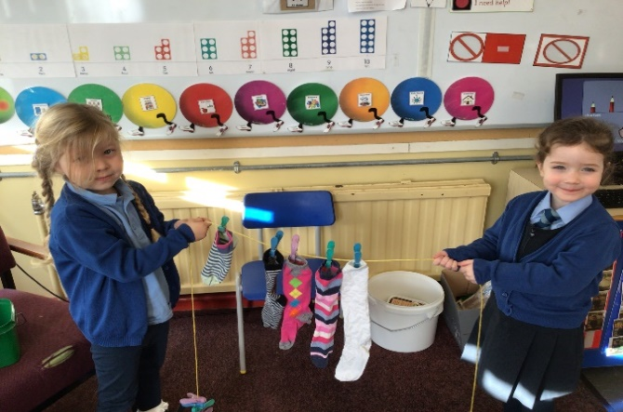

Admissions Information

If the school’s enrolment (136) and admission (19) numbers have not been reached the school will enrol all the children, whose parents wish them to attend. In any year when these numbers are exceeded the Board of Governors will use the following criteria in deciding which pupils should be admitted, both at the enrolment stage (P1) and on transfer from other school (P2-P7).

Admissions Criteria

RESPECTIVE FUNCTIONS OF THE BOARD OF GOVERNORS AND PRINCIPAL IN RELATION TO ADMISSIONS

The Board of Governors draws up the admissions criteria and delegates its use to an Admissions Sub-Committee, which includes the Principal, the responsibility for applying these criteria. Any reference herein to the term the Board of Governors includes any Sub-Committee appointed by the Board of Governors for the purpose of applying the admissions criteria set out herein.

ADMISSIONS CRITERIA

During the admissions procedure when applying the criteria punctual applications will be considered before late applications are considered. The application procedure opens on 9th January 2024 at 12noon (GMT) and an application submitted by the closing date of 26th January 2024 at 12noon (GMT) will be treated as a punctual application. An application received after 12noon (GMT) on 26th January 2024 will be treated as a late application, this is also the last date and time for processing a change of preference in exceptional circumstances. After 4pm on 31st January 2024 no applications will be processed until after the close of procedure on 25th April 2024.

Priority will be given to children who will have attained compulsory school age at the time of their proposed admission, including those children whose parents deferred their admission to primary school in September 2023 as defined by the new School Age (NI) Act (both groups to be treated equally).

Priority will be given to children resident in Northern Ireland at the time of their proposed admission to the school before those who are not so resident.

When considering which children should be selected for admission, the Board of Governors will only take into account information which is detailed on or attached to the application. Examples of such information include names of brothers and sisters in attendance or previously attended.

The Board of Governors will apply the following criteria in the order indicated to identify which children of compulsory school age should be admitted (including those children whose parents deferred their admission to primary school in September 2023) either at initial admission to education (P1) or on transfer from another school.

In the event that there are fewer applicants complying with a particular criterion than there are places available or remaining, those applicants complying with that criterion will be admitted and the next criterion will be applied to the remaining applicants.

In the event that there are more applicants complying with a particular criterion than there are places available or remaining those applicants complying with that criterion will go forward to be considered under the next criterion, and those not complying with that criterion will be eliminated.

1. Children who at the date of application, have brothers and sisters (half-brothers/sisters, step brothers/sisters. Including those fostered or adopted) in attendance during 2023/2024 school year.
2 Children of employees of the school.
3 Children whose brothers and sisters or Parents/Guardians, half-brothers/sisters, step brothers/sisters, including those fostered or adopted have previously attended the school.
4 The remaining places will be allocated on the basis of the proximity of the child’s home to school, priority being given to those living nearest to the school as measured by walking distance measured by Google Maps UK.

If the final places to be allocated have identical measurements, selection will be on the initial letter of surname (as entered on birth certificate) in the order set out below

F P E I A S W V B U K G Z Q M H L O N C D Y T R J X

This order was determined by a randomised selection of the letters of the alphabet (selection with a clear audit trail). In the event of surnames beginning with the same initial letter the subsequent letters of the surname will be used in alphabetical order. In the event of two identical surnames the alphabetical order of the initials of the forenames will be used, and if necessary the subsequent letters of the forenames.

DUTY TO VERIFY

The Board of Governors reserves the right to require such supplementary evidence as it may determine to support or verify information on any application form.

If the requested evidence is not provided to the Board of Governors by the deadline given, this will result in the withdrawal of an offer of a place. Similarly, if information is supplied which appears to be false or misleading in any material way, the offer of a place will be withdrawn.

WAITING LIST POLICY

The school’s policy on the consideration of applications to primary one after the open enrolment admissions procedure concludes is detailed below.

Should a vacancy arise after this date all applications for admission to the school that were initially refused, new applications, late applications and applications where new information has been provided will be treated equally and the published criteria applied. This waiting list will be in place until the end of the academic year.

The school will contact you in writing if your child gains a place in the school by this method.

Your child’s name will be automatically added to the list. Please contact the school if you wish your child’s name to be removed from the list.

ADMISSION TO P2 – P7

The same criteria used to admit pupils to primary one will be used for applications to join primaries two – seven.

Applications and Admissions to Primary 1
Year | Total Applications | Total Admissions
2021/2022 | 17 | 15
2022/2023 | 19 | 18
2023/2024 | 17 | 17

